Link: https://acadgild.com/blog/transactions-in-hive/

1. Problem Statement Link:

https://acadgild.com/blog/transactions-in-hive/

Refer the above given link for transactions in Hive and implement the operations given in the blog using your own sample data set and send us the screenshot.

Note: Hive 0.14 should be installed to implement the hive transaction property.

Commands executed

set hive.support.concurrency = true;

set hive.enforce.bucketing = true;

set hive.exec.dynamic.partition.mode = nonstrict;

set hive.txn.manager = org.apache.hadoop.hive.ql.lockmgr.DbTxnManager;

set hive.compactor.initiator.on = true;

set hive.compactor.worker.threads = 2;

show databases;

use default;

CREATE TABLE student3(std_id int,std_name string,std_class string) clustered by (std_id) into 5 buckets stored as orc TBLPROPERTIES('transactional'='true');

INSERT INTO table student3 values(1,'ravi','LKG'),(2,'gopi','UKG'),(3,'RAHUL','1st'),(4,'ARAVIND','2nd'),(5,'REHMAN','3RD');

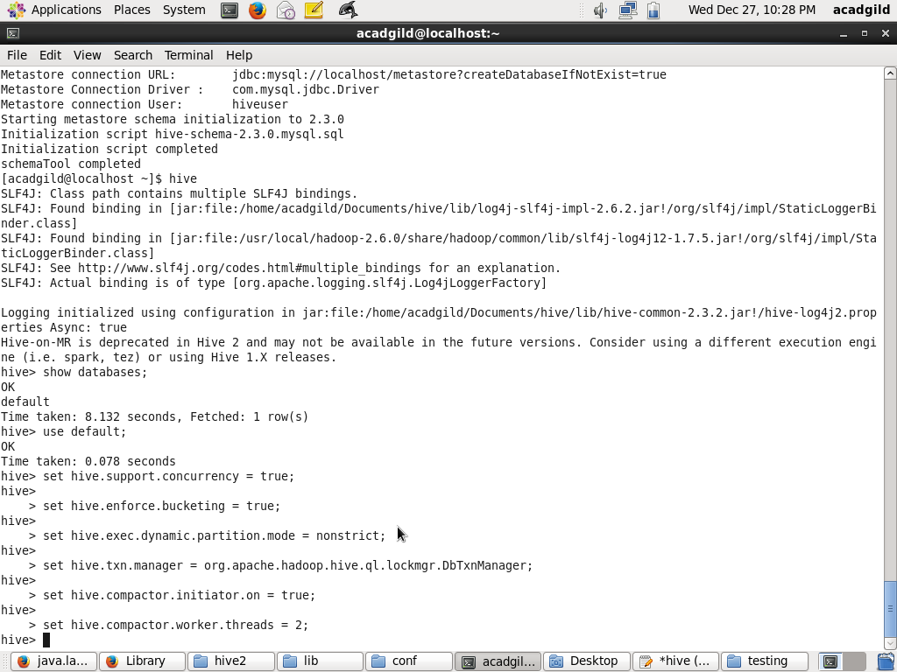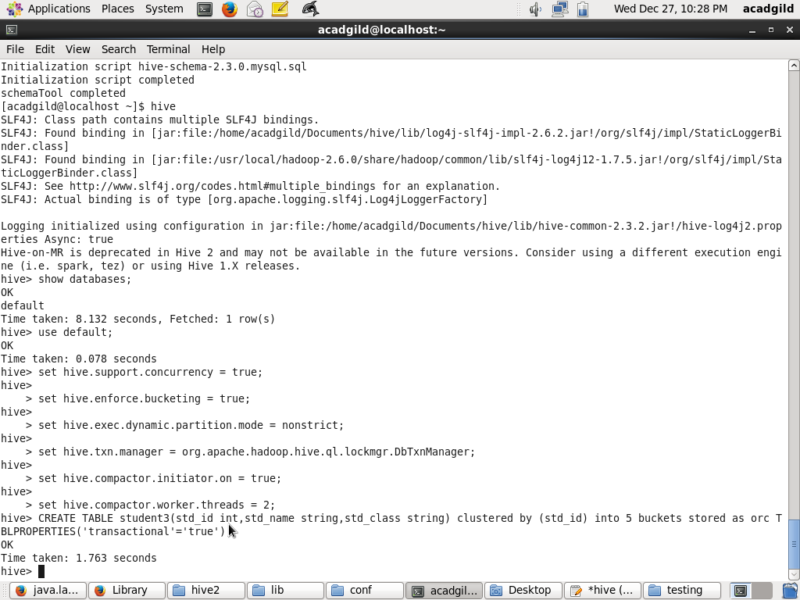

**Insert records**

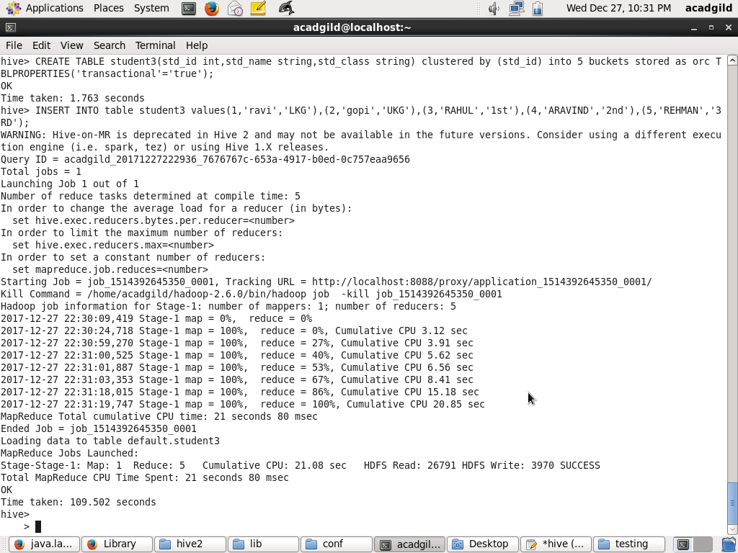

Delete records

delete from student3 where std_id=1;

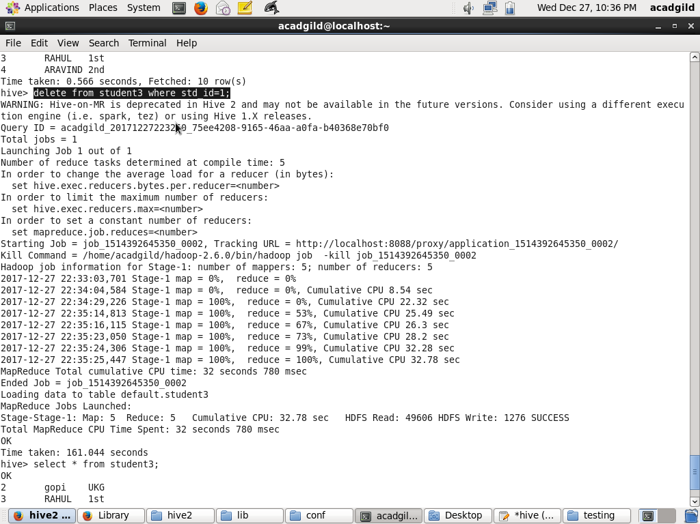

Update records

update student3 set std_class='5th' where std_id=4;

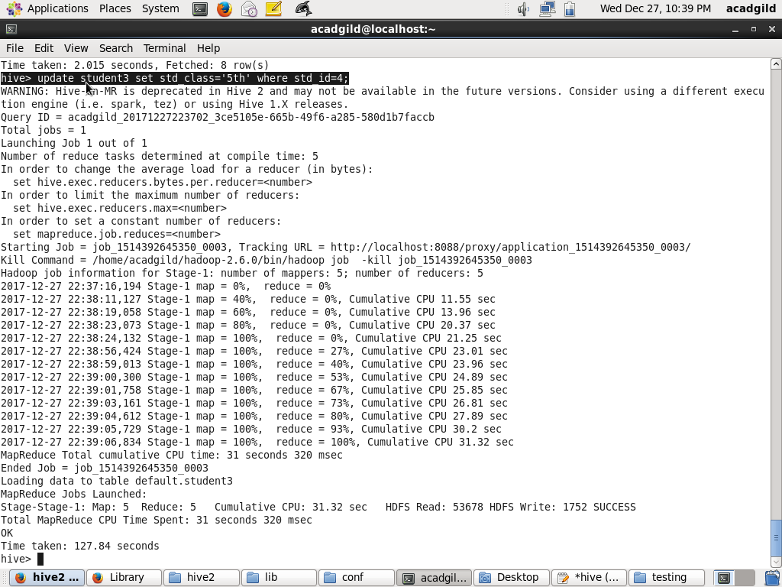

After Update Records

